🚀 AWS EC2 Web Server Deployment Project
📌 Project Overview
This project demonstrates how to launch and configure an AWS EC2 instance to host a simple web server.
It focuses on secure access, basic networking, and operational best practices, which are core skills for Cloud Support and Cloud Operations roles.

🏗️ Architecture Diagram (Simple)
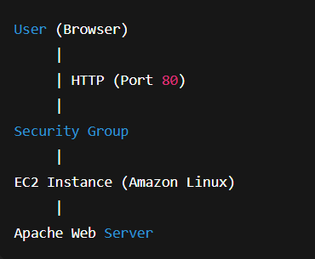Components Used:
- AWS EC2
- Security Groups
- Key Pair
- Amazon Linux AMI
- Apache Web Server

⚙️ Steps to Launch EC2 Instance
- Login to AWS Console
  - Navigate to EC2 service
  - Select appropriate AWS region
- Launch EC2 Instance
  - AMI: Amazon Linux 2
  - Instance Type: t2.micro (Free Tier)
  - Key Pair: Create or select existing key pair
- Configure Network
  - Default VPC
  - Public subnet
  - Auto-assign public IP enabled
- Configure Security Group
  - Allow required inbound traffic (see below)
- Launch Instance
  - Verify instance state is running
- Install Web Server
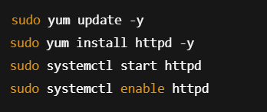
- Verify Web Server
  - Access EC2 public IP in browser
  - Apache test page should load successfully

🔐 Security Group Rules
Type | Protocol | Port | Source | Purpose
SSH | TCP | 22 | My IP | Secure server access
HTTP | TCP | 80 | 0.0.0.0/0 | Web access
HTTPS (Optional) | TCP | 443 | 0.0.0.0/0 | Secure web traffic

Security Best Practices Followed:
- SSH restricted to specific IP
- No unnecessary ports opened
- Key-based authentication used

📘 Lessons Learned
- Understanding EC2 lifecycle management
- Importance of security group configurations
- Real-time troubleshooting of connectivity issues
- Hands-on experience with Linux commands
- How cloud infrastructure supports scalable applications
- Practical exposure to AWS networking & access control

